**Week 1 Tasks**

**Task 1 – Glossary of terms**

Save the file: Glossary of terms to your Unit 2 folder. As you complete each task add explanations or simplified terms in your own words. This is to be a revision document and you will add to it each week.

**Task 2 – create a relation**

In a relational database terminology, a table of data is known as a **relation**. Every relation has columns which represent the different data that is stored in the relation. In the customer details table example below, this would be items like customer number, customer first name, customer surname, house number and postcode. Each of these items is called an **attribute.** Each attribute has a range of allowable values which is known as a **domain**.

|  |  |  |
| --- | --- | --- |
| **Attribute** | **Domain name** | **Domain definition** |
| Customer Number | CUST_NO | Numeric |
| Customer first name | F_Name | Character, size 25 |
| Customer surname | S_Name | Character, size 25 |
| Address line 1 | Addr_1 | Character, size 25 |
| Address line 2 | Addr_2 | Character, size 25 |
| Town | Town | Character, size 25 |
| Postcode | Postcode | Character, size 8 |
| Date of Birth | DOB | Date/time |

Use MS Access to create the relation (table) above in a new database named Table Tools. Ensure you save it in Unit 2

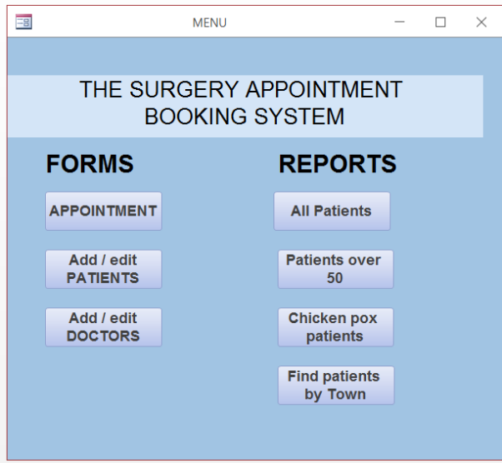**Task 3 – Experiment with the Appointment system database. MAKE NOTES as you complete all the tasks – take screen shots if it is helpful.**

1. Click on **PATIENTS** button – add yourself as a new patient. **Note** down what happens when you try to add data to each field.
2. Click on **APPOINTMENT** button
   1. – make an appointment for yourself (select from the drop down menu).
   2. Add date and time of appointment + symptoms & treatment
   3. Type in a Doctor ID (1, 2, 3 or 4)
3. **Note** how easy / difficult it was to add yourself. How easy/difficult to add a doctor.
4. Save and exit to main menu.
5. Run the ALL patient report. Did you find your name?
6. Run the Patient’s over 50 report. Did you find your name?
7. Edit your date of birth to 2/2/1967 – re run the report
8. Run the Find patients by town – enter: Tonbridge – what happens?
9. Run the Find patients by town – enter: Tunbridge Wells – what happens?